Data Visualization using TABLEAU

**Problem Statement:**

Visualization Method using Tableau Techniques for the Claim Insurance dataset given.

**Tableau Public Link:**

<https://public.tableau.com/profile/ashwin3767#!/vizhome/sheet3_15802724756270/Story1>

**DataSet Information:**

|  |  |
| --- | --- |
| ID | Id of customer |
| KIDSDRIV | Total No of kids the car driver has |
| BIRTH | Date of birth |
| HOMEKIDS | No of kids the driver has at home |
| YOJ | Year in which the car owner applied for the car insurance policy |
| INCOME | Income |
| PARENT1 | If car owner has his parents |
| HOME_VAL | Value of the house owned |
| MSTATUS | Marital status |
| GENDER | Gender |
| EDUCATION | Education level |
| OCCUPATION | Occupation level |
| TRAVTIME | Travel time taken in minutes(On an average) |
| CAR_USE | Purpose of using the car |
| BLUEBOOK | What is the worth of the car |
| CAR_TYPE | Car type |
| OLDCLAIM | Previous claim |
| CLM_FREQ | How often claimed |
| CLM_AMT | Currently Claimed amount |
| CAR_AGE | Age of car |
| URBANICITY | Where the car is being driven primarily |

**Below is the observation from below Tableau Graph:**

**Dashboard- 1 :: General Information**

1. **Gender Ratio**

46.14 % are Male

53.85 % are Female

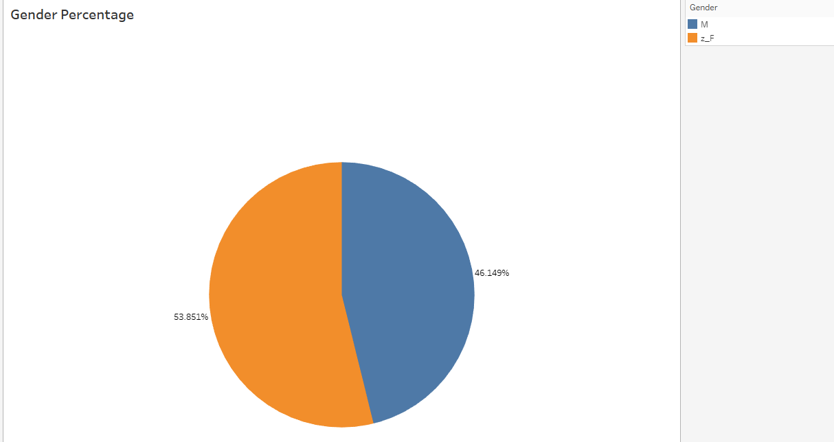

1. **Married Status against Gender**

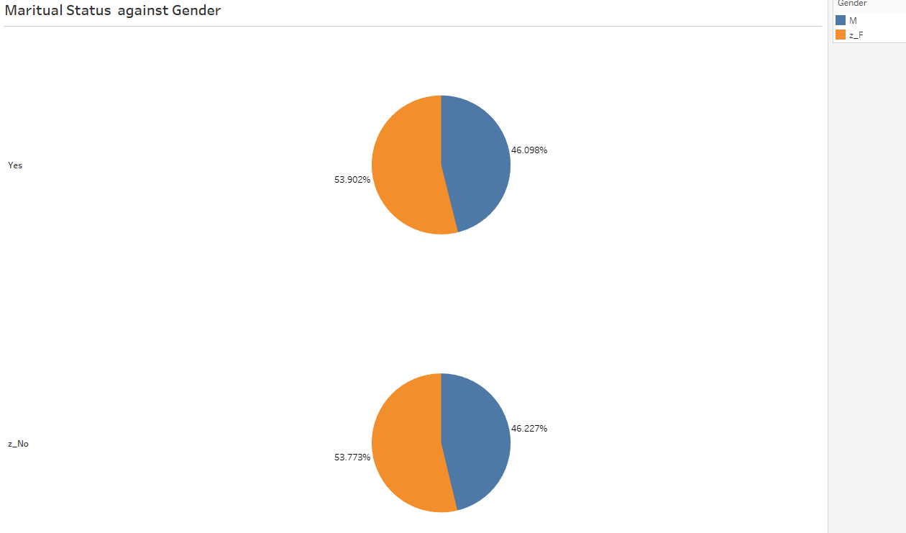

1. **Gender against Rural and Urban**

* Major population is based from Urban for both male and female
* 37% male resides in Urban and 8.36 % male resides in rural area
* 42% female resides in Urban and 11.7% female resides in rural area

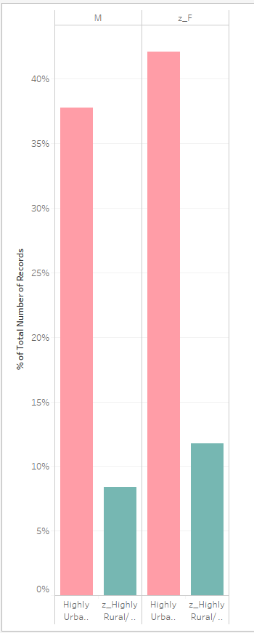

1. **Claim Frequency against vehicle**

* SUV has maximum number of claims submitted
* Panel Truck has low number of claims submitted

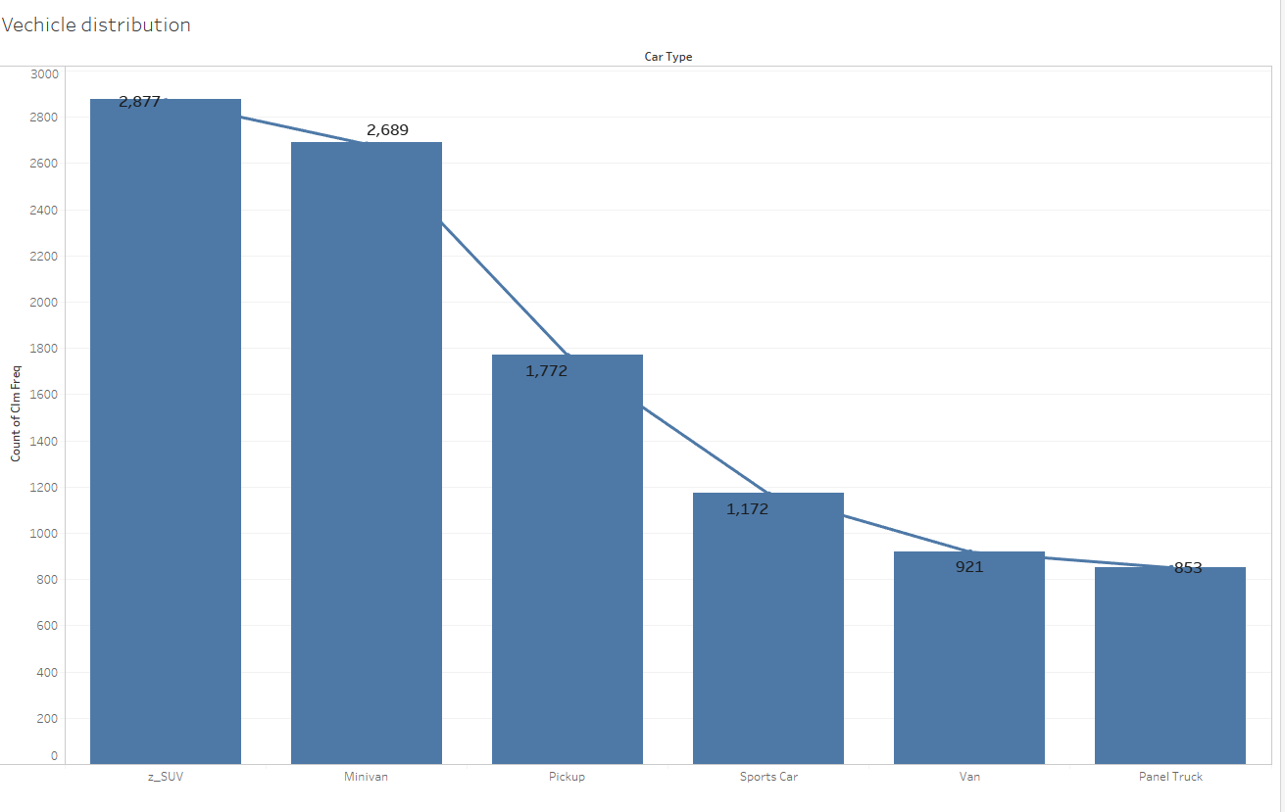

**Dashboard – 2: Insights from Vehicle**

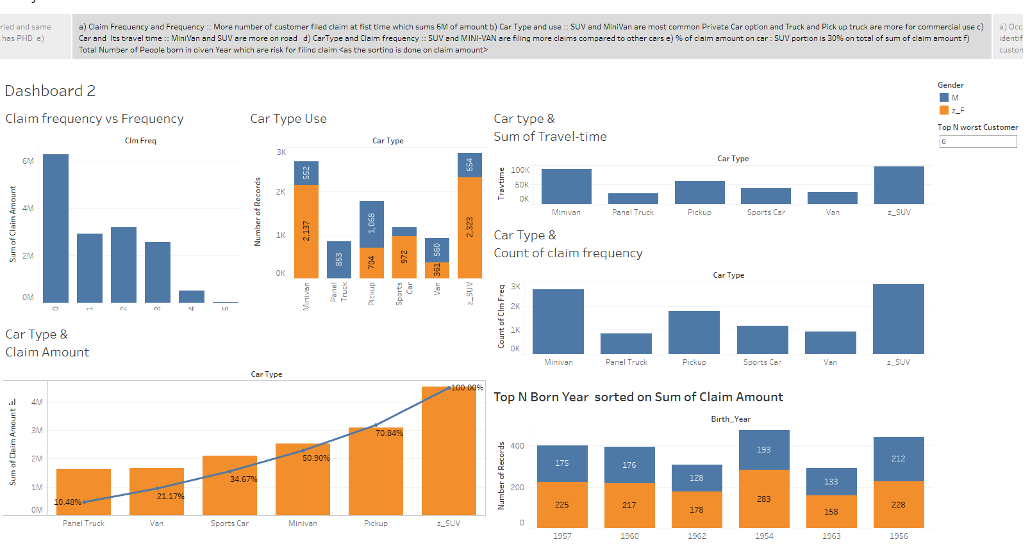

**Observations:**

1. More Claims are submitted for 1st time claim
2. SUV and MINI-Van is more popular for Personal Use
3. Panel Truck and Pickup truck is popular from Commercial Use
4. Car Type and Claim-frequency and travel-time is more for SUV and MINI-Van.
5. % of claim submitted in total claim amount is more for SUV and then PICKUP truck.

**More insight from Tableau Visualization:**

Graph of Car-Age and Number of Claim Submitted:

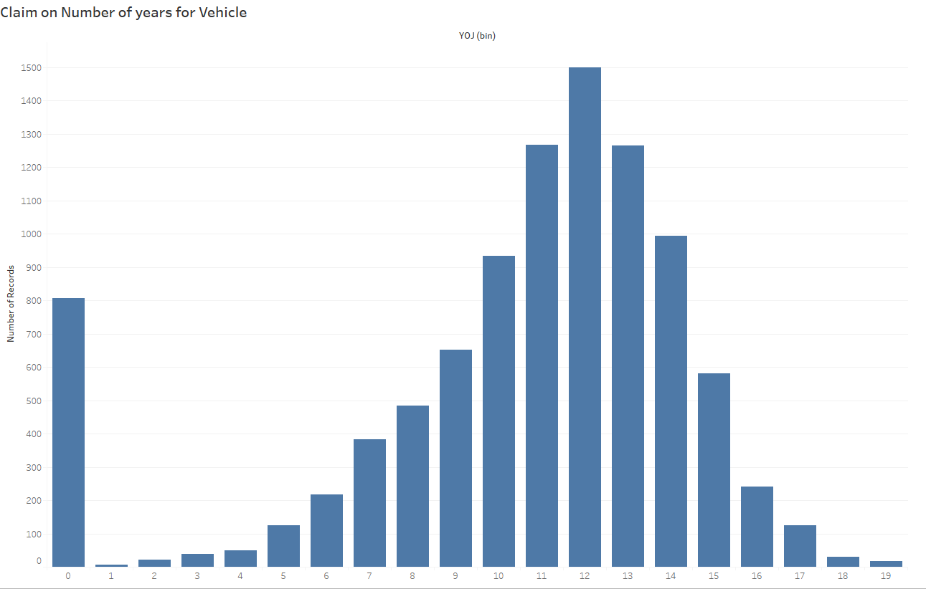

**Observation:**

More claims are filed when the car is 12 years age and which are prone to accident.

**Dashboard 3: Occupation and Dynamic Information for Good/Bad Customer**

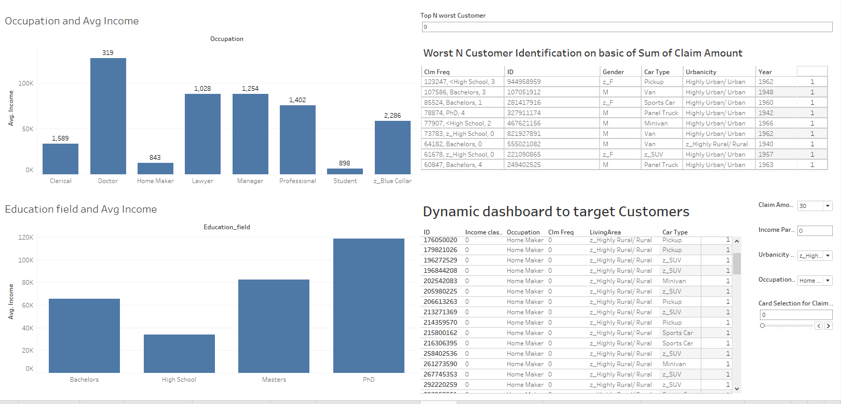

**Conclusion:**

1. Dynamic dashboard to use to identify Good Customer marked as Safe Drivers

No claims submitted so far.

People born is year (1950 – 1960) are having more accident

1. Dynamic Dashboard to target worst Customer depending the sum of Claim Amount submitted

Worst Customer are identified sum of number of claim amount submitted.

Rural area prone to less accident

Heavy vehicle PICKUP TRUCK and Panel truck and sports car are the customers which are submitting more claims